Template for abstracts - TITLE
Name¹, Name², …
¹Institute or Department, University or Company, Street Address, City, Country
²Institute or Department, University or Company, Street Address, City, Country
presenting.author@email.com
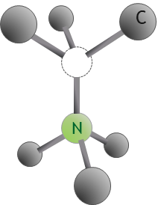
Figure 1 - Optional caption, size 10, italics, centred below the figure
Keywords: max. 4

Please use this template to prepare your abstract. The main text is Tahoma font, 11 point. Type or paste your text into this file, but keep the page margins the same as is set here which is 2.5 cm all round. Paragraphs are justified (straight-edged) on both left and right. Use single-line spacing and leave a line gap between paragraphs. Please do not change any spacing, fonts, margins, or sizes, and keep the text justified.
Figures are optional. Use the insert picture command and paste special as an enhanced metafile for ease of handling. Please set the text to flow around the figure, and include a figure caption.
The limit for your abstract is one page. Abstracts that do not meet these formatting requirements will be returned.
The abstract deadline is November 22, 2022. There is no fee for submission of an abstract, but a separate fee-based registration for the conference is required. You will be notified if your abstract is selected. All accepted abstracts will be published for the participants on the QuApps website.
The organizing committee reserves the right to edit abstracts for clarity or correctness of English, but will consult the author if any significant changes are needed.
References

